SOFTWARE TESTING REPORT
Module Name: Login Page - Functional & UI Test Cases
Test Case ID: TC001
Webpage URL: https://www.saucedemo.com/?
Scenario ID: 1a
Scenario: Login with valid credentials
Test Steps:
- Click on sign up
- Enter Username and password
Test Input: Username: standard_librarian
Password: secret_sauce
Expected Result: User should log in successfully and the Products page should be displayed.
Actual Result: Product page is displayed
Status: Pass
Screenshot:
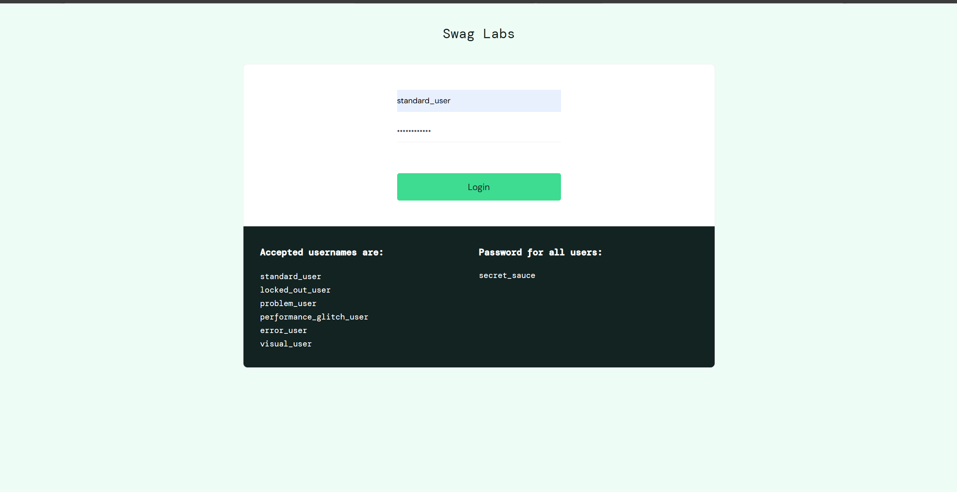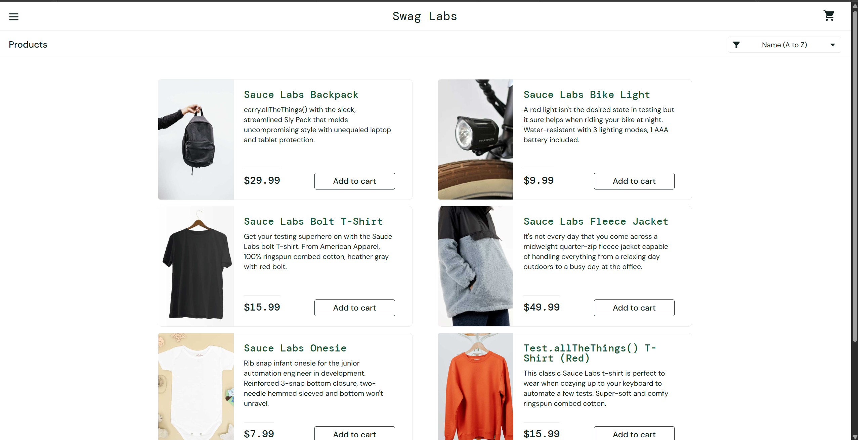
Scenario ID: 1b
Scenario: Login with valid username and incorrect password
Test Steps:
- 1. Open the Swag Labs login page.
- 2. Enter username: standard_user.
- 3. Enter an incorrect password.
- 4. Click Login.
Test Input: Username: standard_user
Password: wrong_password
Expected Result: An error message should appear and login should be denied.
Actual Result: An error message appears
Status: Pass
Screenshot:
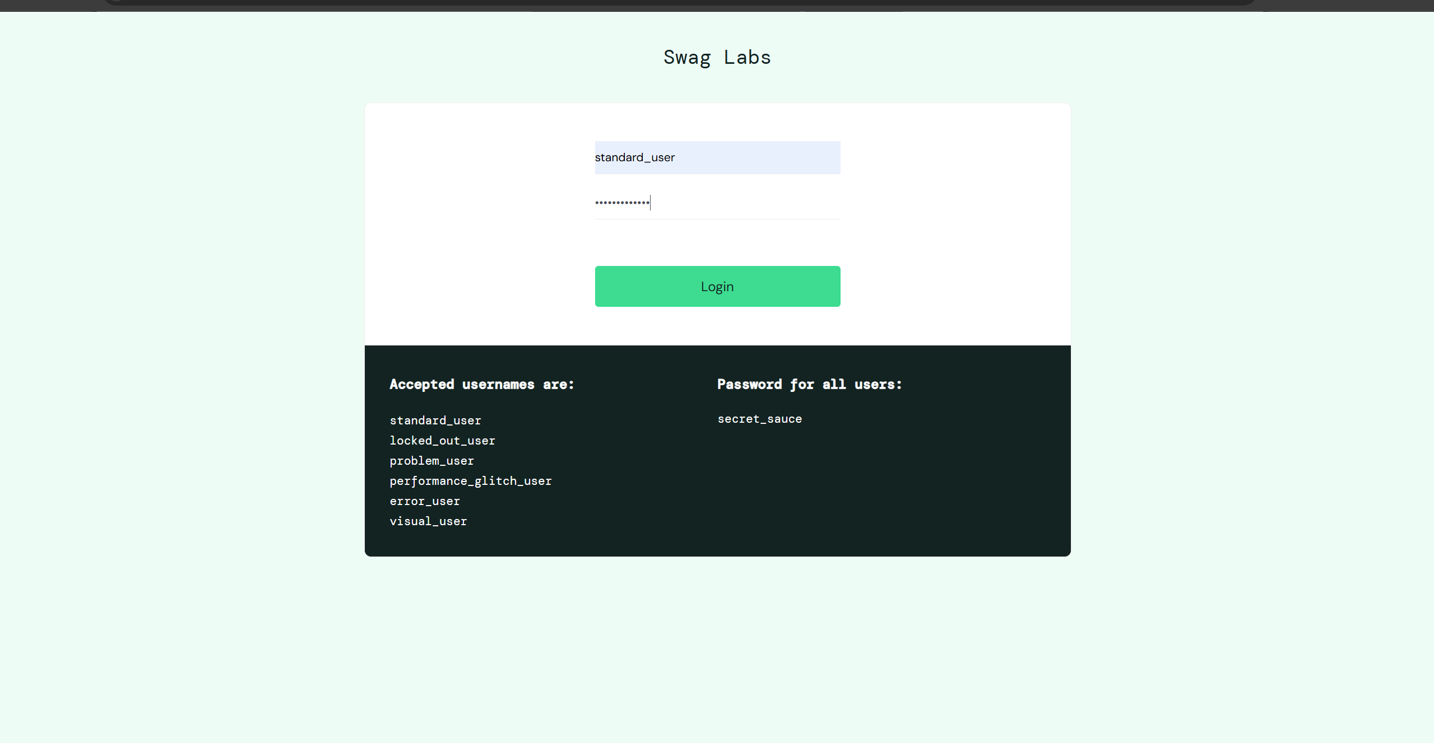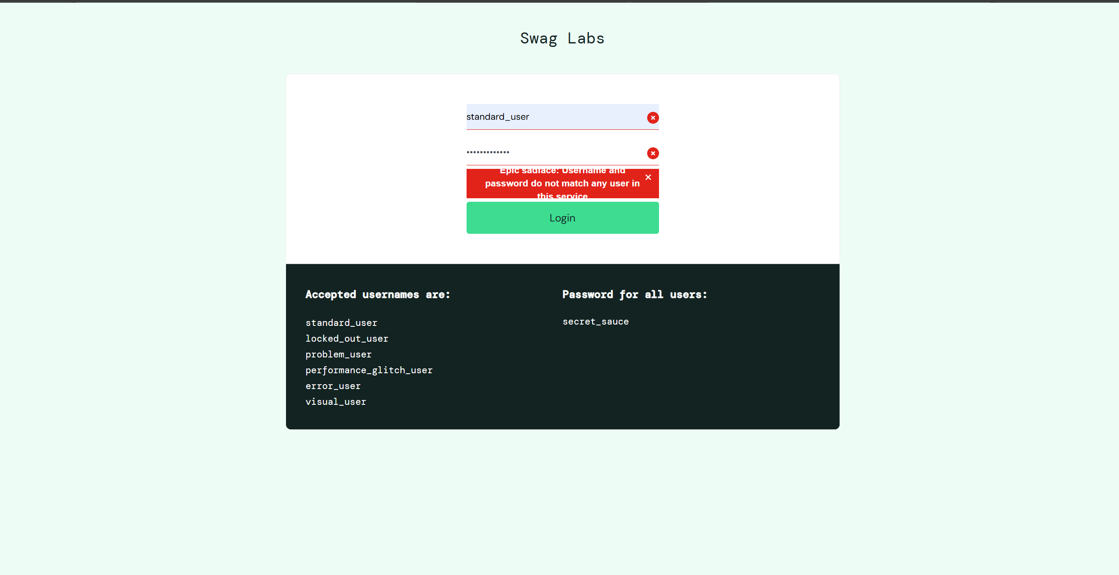
Scenario ID: 1c
Scenario: Login with empty username and password
Test Steps:
- 1. Open the Swag Labs login page.
- 2. Leave the username field empty.
- 3. Leave the password field empty.
- 4. Click Login.
Test Input: Username: Blank
Password: Blank
Expected Result: An error message should appear indicating required login information; login should be denied.
Actual Result: Error message is appearing
Status: Pass
Screenshot:
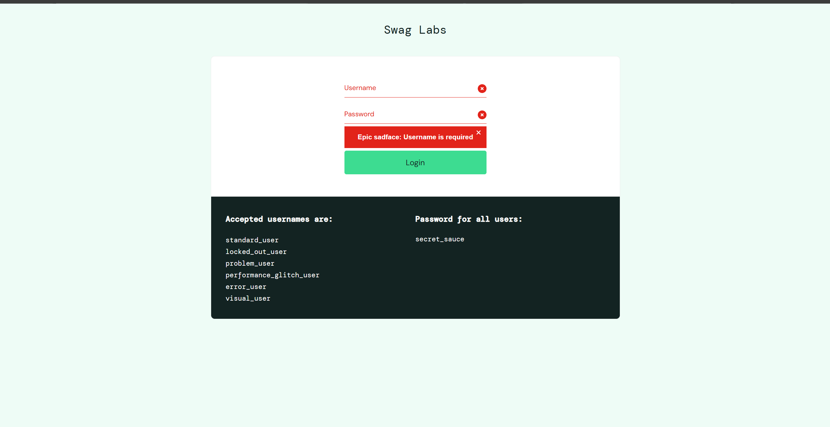
Scenario ID: 1d
Scenario: Enter with only whitespace inputs
Test Steps:
- 1. Open the Swag Labs login page.
- 2. Enter username: “ “
- 3. Enter password: “ ”
- 4. Click Login.
Test Input: Username: “ “
Password: “ ”
Expected Result: An error message should indicate that the user has been locked out.
Actual Result: error message is displayed
Status: Pass
Screenshot:
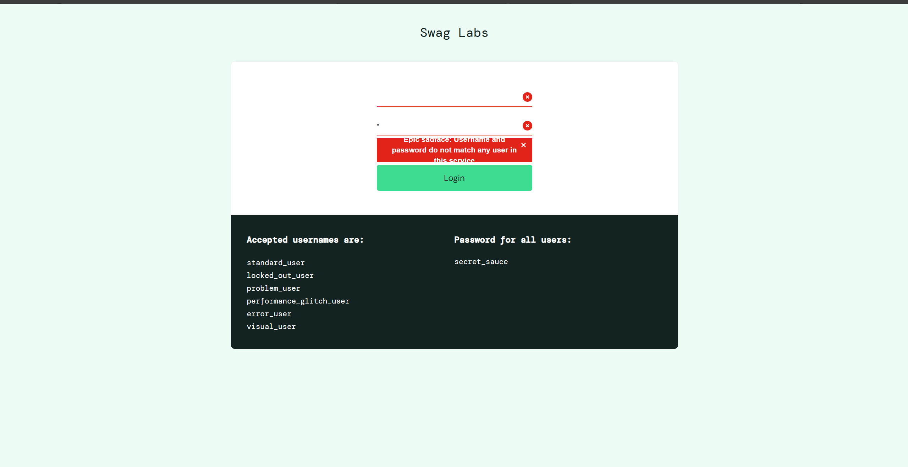
Scenario ID: 2c
Scenario: Login with invalid username
Test Steps:
- 1. Open the Swag Labs login page.
- 2. Enter an unrecognized username.
- 3. Enter password: secret_sauce.
- 4. Click Login.
Test Input: Username: invalid_user
Password: secret_sauce
Expected Result: An error message should appear and login should be denied.
Actual Result: Error message is displayed for invalid username
Status: PASS
Screenshot:
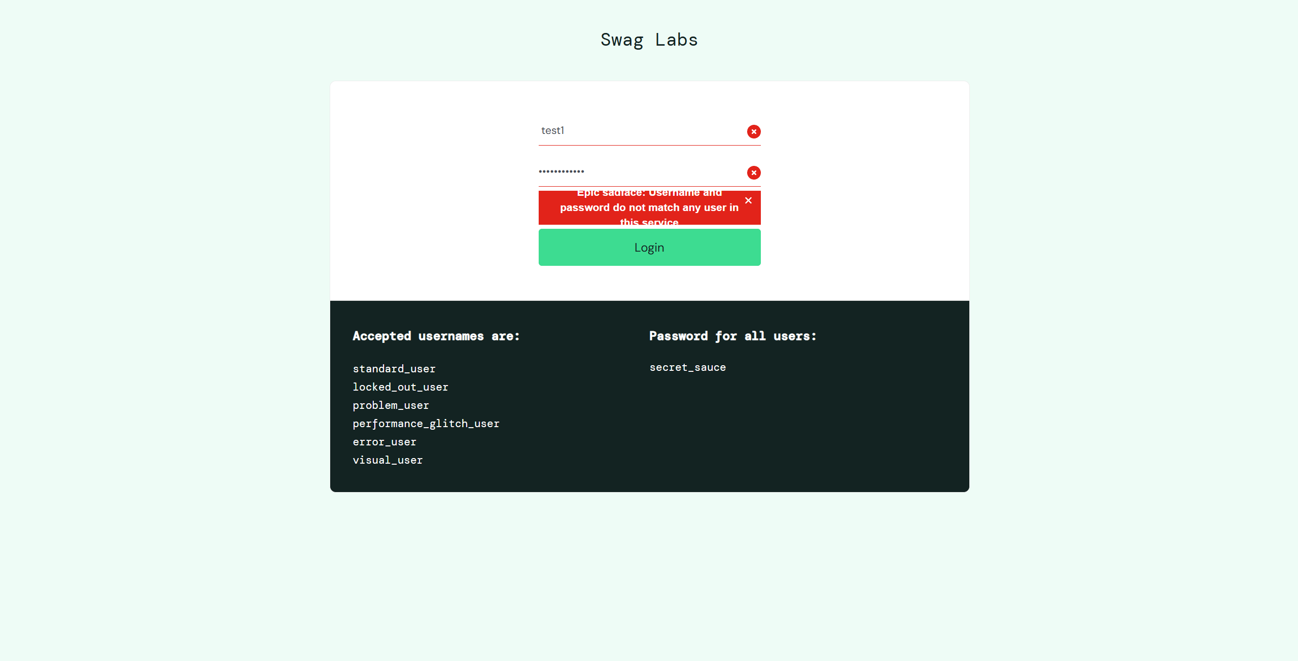

Summary of Test Results
Total Test Scenarios | 5
Passed | 5
Failed | 0
Pass Percentage | 100

Conclusion and Recommendations
The report covers five login scenarios for the Swag Labs application. Execute each scenario, insert the corresponding screenshot, and update the Actual Result and Status fields before final submission.
Recommendation: Verify that successful login opens the Products page and that invalid, empty, and locked-out credentials are handled with clear error messages.

